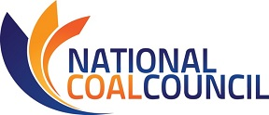

2019 SPRING ANNUAL MEETING
April 11-12, 2019 – Marriott Wardman Park Washington, D.C.

35th Anniversary Celebration
1984|2019

NCC MEETING REGISTRATION
Fax: 732-231-6581 or Email info@NCC1.org this registration form.
Please register for the meeting no later than March 11, 2019
Name:
Title:
Company:
Phone:
Address:
Email Address:
Guest Name(s):
Guest Company & Email:

I will attend the following events ~ Note: You will be invoiced for lunch, dinner, & sponsorships.

Thursday, April 11th, 2019
_____ *NCC Dinner 6:00-9:00 pm $175 individual seat ($75 government employee)
_____ Please reserve a priority dinner table of 8 for me @ discounted rate of $1200

Note: Counsel has advised that under House and Senate rules, this is a “widely attended event.” Under these rules, only NCC may extend invitations to House or Senate Members or staff to attend this event. Individual members of NCC are not permitted to extend invitations. Please contact the NCC office if you wish us to extend an invitation to Congressional members/staff on your behalf. Violations of these rules may result in criminal liability.

Friday, April 12th, 2019
_____ NCC Full Council Meeting 8:30 am-Noon
_____ *Buffet Lunch Noon $50

*No refunds after March 29th. Refunds prior to March 29^{h} subject to 5% service fee. *
Attention NCC Members: Travel reimbursement must be received by DOE no later than March 11th, 2019.
Full details of the travel reimbursement policy may be found at
Travel Reimbursement Procedures for Qualifying NCC Members.

35th Anniversary Celebration
1984|2019

April 11th NCC Dinner Sponsorship Opportunities

_____$4000 Jade Sponsor
- Acknowledgement as drinks reception sponsor.
- Four (4) seats at dinner w/priority seating.
- Company logo included on sponsorship banner and NCC website.
- Sponsorship acknowledgement on PowerPoint at NCC Full Council Meeting.
- Verbal recognition of sponsorship during dinner and NCC Full Council Meeting.

_____$3000 Emerald Sponsor
- Acknowledgment as dessert station sponsor.
- Three (3) seats at dinner w/priority seating.
- Company logo included on sponsorship banner and NCC website.
- Sponsorship acknowledgement on PowerPoint at NCC Full Council Meeting.

_____$2000 Sapphire Sponsor
- Acknowledgment as coffee station sponsor.
- Two (2) seats at dinner w/ priority seating.
- Company logo included on sponsorship banner and NCC website.

April 12th NCC Full Council Meeting Sponsorship Opportunities

_____ Event Sponsor (includes Hotel Keycard sponsorship) ~ $2500
_____ Keynote Session Sponsor (special acknowledgement at opening session) ~ $1000
_____ Breakfast ~ $1000
_____ Break/Coffee ~ $750
_____ Buffet Lunch Sponsor ~ $750
_____ WIFI Sponsorship ~ $500
(Company name featured on NCC Full Council Meeting Welcome PowerPoint)
_____ 35th Anniversary Program Sponsor (logo featured in NCC meeting Program) ~ $250

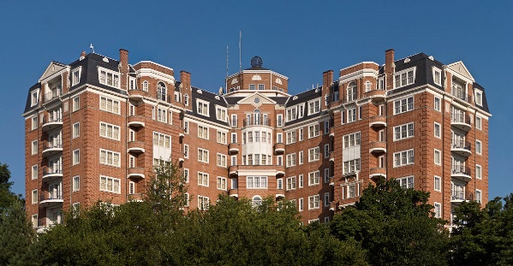
2019 SPRING ANNUAL MEETING
April 11-12, 2019 ~ Washington, D.C.

Hotel Reservations
All events will be hosted at Marriott Wardman Park, Washington, DC
2660 Woodley Road NW, Washington, DC 20008
Deluxe guest room rates are $269.00 per night
Reservations must be made by March 11th to secure this rate.
Rooms can be reserved by calling 1-877-212-5752 and requesting
National Coal Council 2019 Spring Meeting
For Online Reservations: https://book.passkey.com/e/49804636

Disclaimers
Photo Release

The National Coal Council, its successors and assigns, retain the right and permission to publish, without charge, photographs taken during this event. These photographs may be used in publications, including electronic publications, or in audio-visual presentations, promotional literature, advertising, or in other similar ways. By attending the event, you agree to the foregoing,

Medical Release

Conference attendees acknowledge and agree that as a result of their registration and participation in the event, they hereby assume responsibility for their own well-being and safety. Attendees assume the risk in taking part in any voluntary off-site activities and attendees, their heirs, assigns and representatives hereby agree to indemnify and release the National Coal Council, its directors, officers, employees and agents from all liability, claims, demands or losses caused, in whole or in part, by attendee’s participation in the event or other activities including third party activities.

